**ASSIGNMENT 1.2**

1. **What should be the output of the following Script?**

v <- c( 2,5.5,6)

t <- c(8, 3, 4)

print(v%/%t)

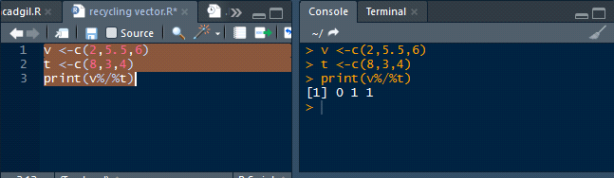

2. **You have 25 excel files with names as xx_1.xlsx, xx_2.xlsx,........xx_25.xlsx in a dir.**

**Write a program to extract the contents of each excel sheet and make it one df.**

setwd("Path containing your excel files")

files-list.files(pattern=".xlsx")

for(i in 1:length(files)) {

filename-files[i]

data-read.xlsx(file = filename.header-T)

assign(x filename,value data)

}

3. **If the above 25 files were csv files, what would be your script to read?**

First we need to save the excel sheets into .csv files and import/read it using CSV method.

setwd("Path containing your excel files")

files-list.files(pattern=".csv") {

for(i in 1:length(files))

filename-files[i]

data-read.csv(file = filename.header-T)

assign(x filename,value data)

}